COP_6731_access_oracle_v2

[Link to Dr. Yang’s Instructions – FAU Oracle Database Access](https://faculty.eng.fau.edu/yangk/COP6731/setup.html)

Table of Contents

Access VMware through portal 3

Log in to the Engineering Desktops 5

Access the terminal from the windows desktop (in VMWare) 7

SSH into oraclelinux.eng.fau.edu 8

Enter Oracle database server with SQL*Plus command 9

Create table (example) 10

Create spool file 11

End spool file with spool off command & then exit 11

Verify spool file is present with either ls -al or ls 12

Exit to VMware desktop 12

sftp to get spool file and download it to VMware desktop & exit 13

Find spool file in VMware desktop 13

Make sure the spool file has all the SQL queries and the correct output 16

Upload the spool file from the VMware desktop 16

Change linux password 20

Change Oracle password 20

* Note: these are some basic steps and just one way to approach the process

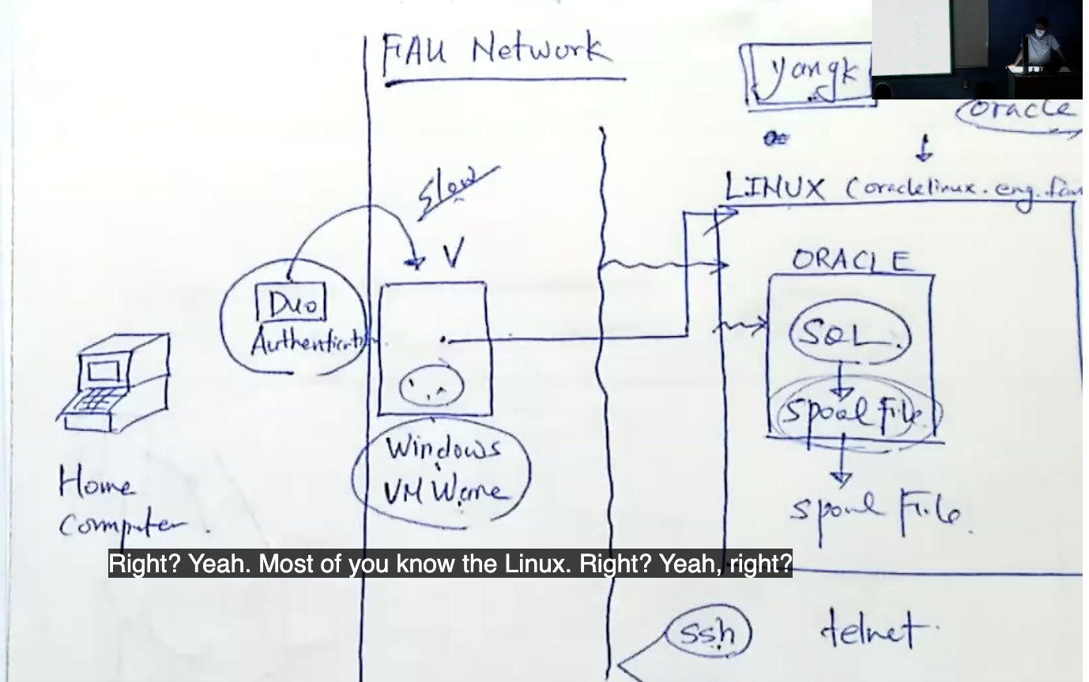

Diagram from class 1/24/23

Di

# Access VMware through portal

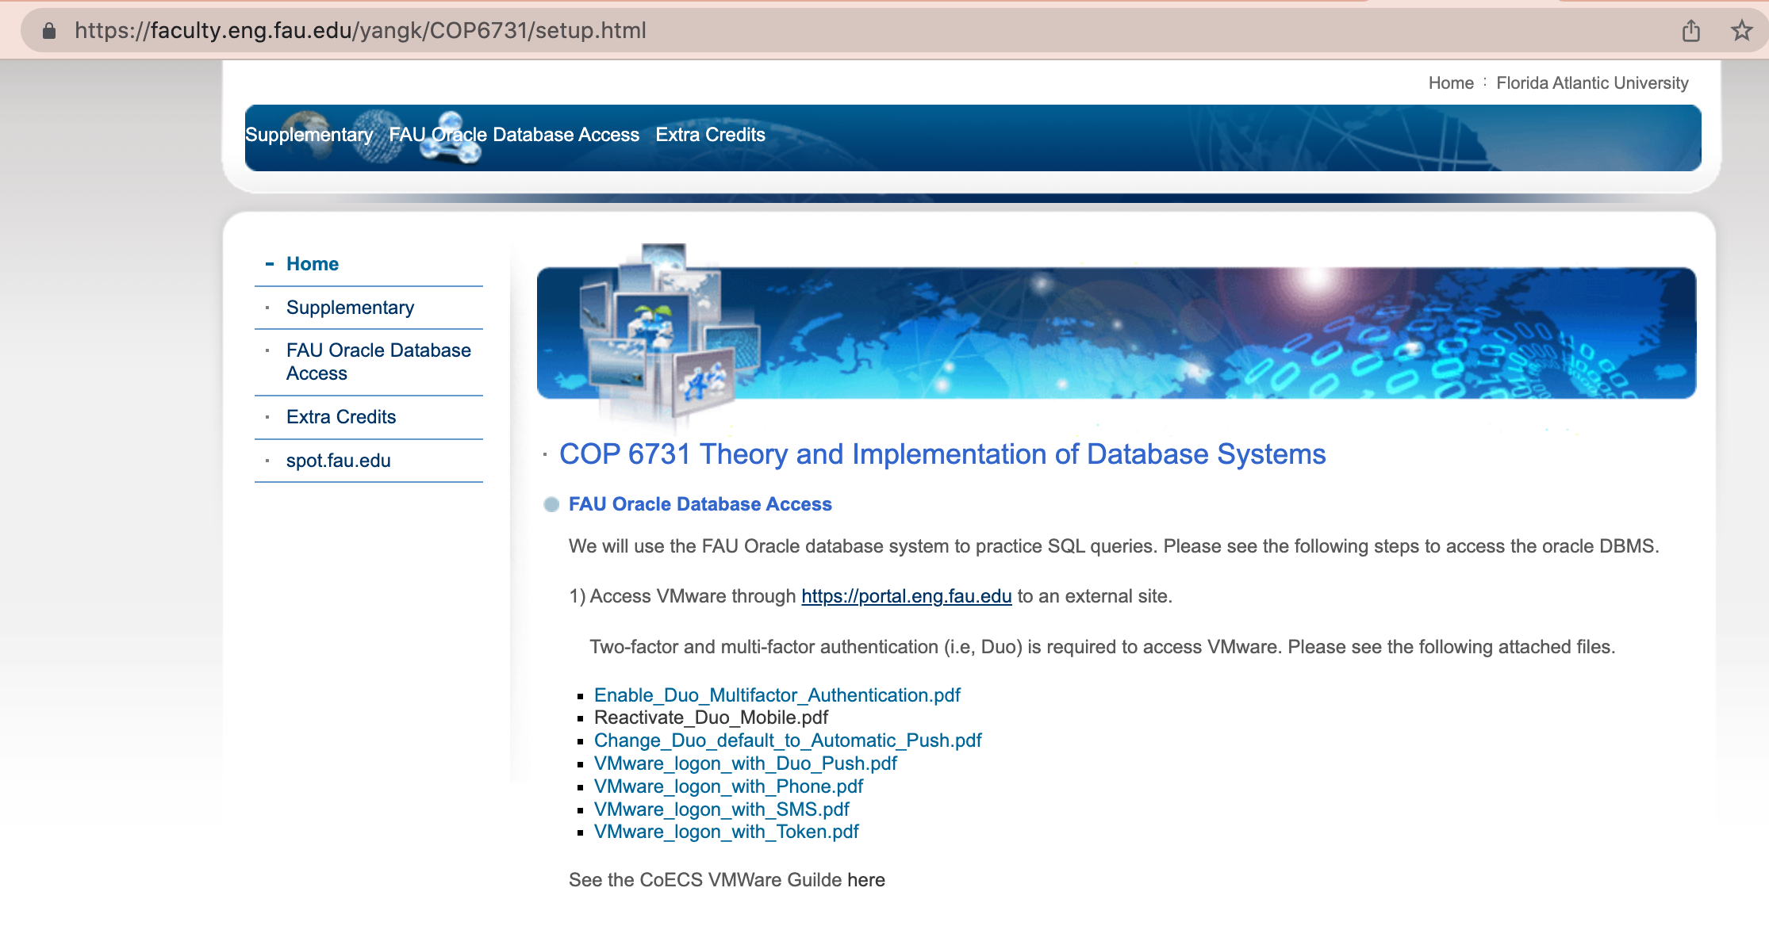

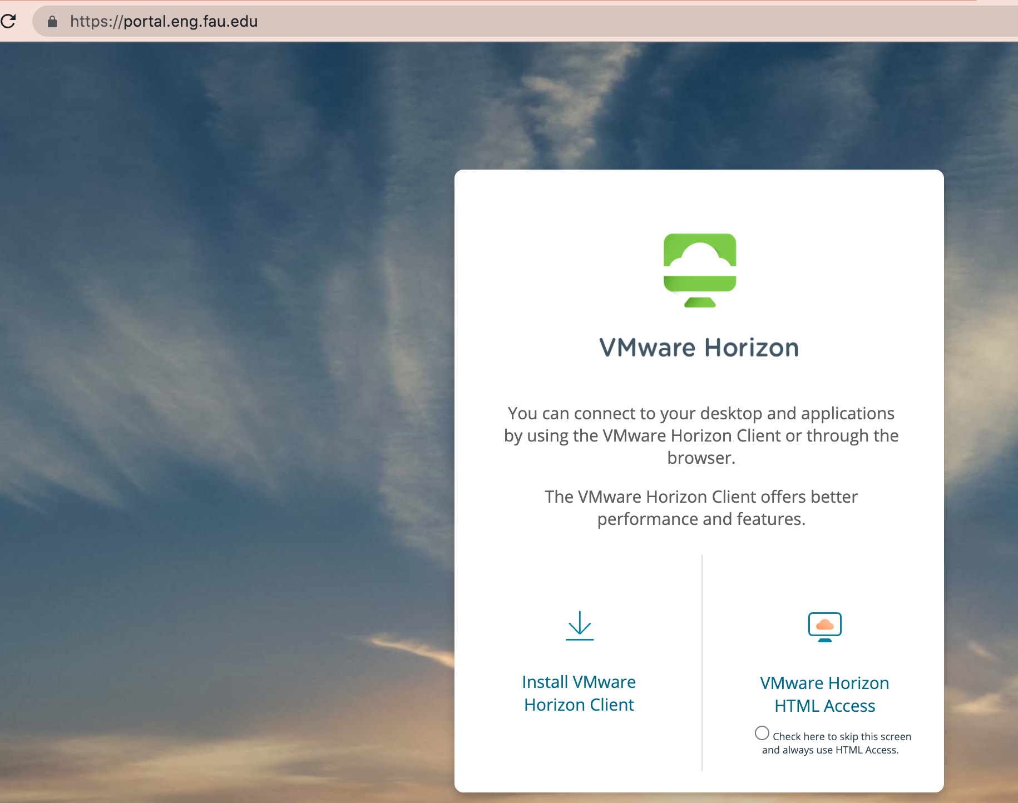

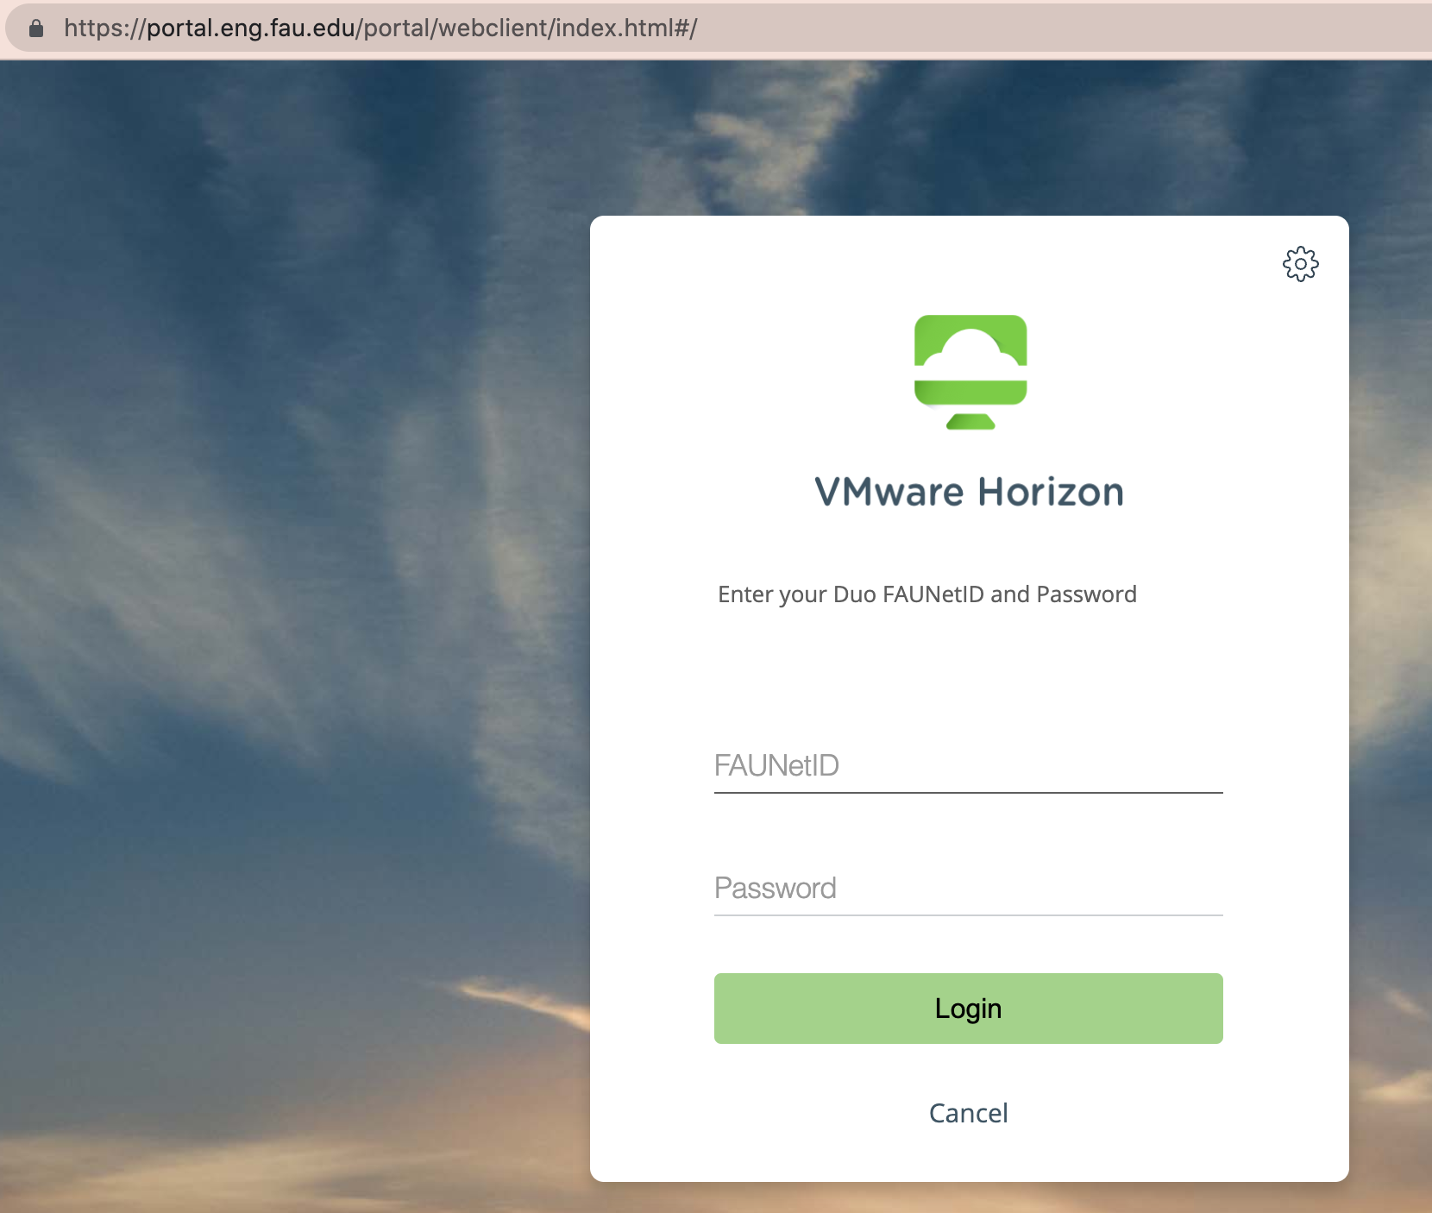

# Log in to the Engineering Desktops

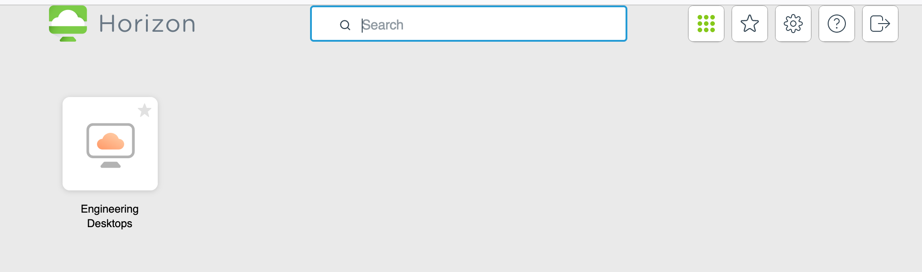

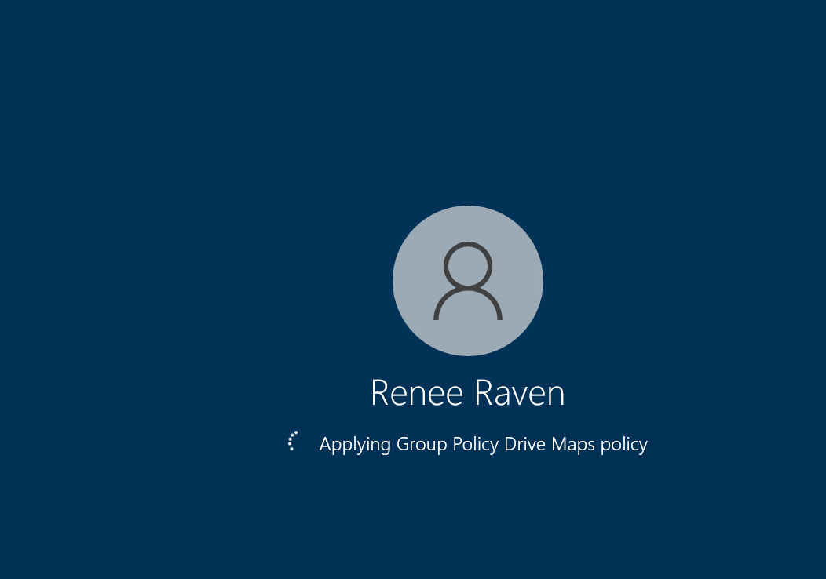

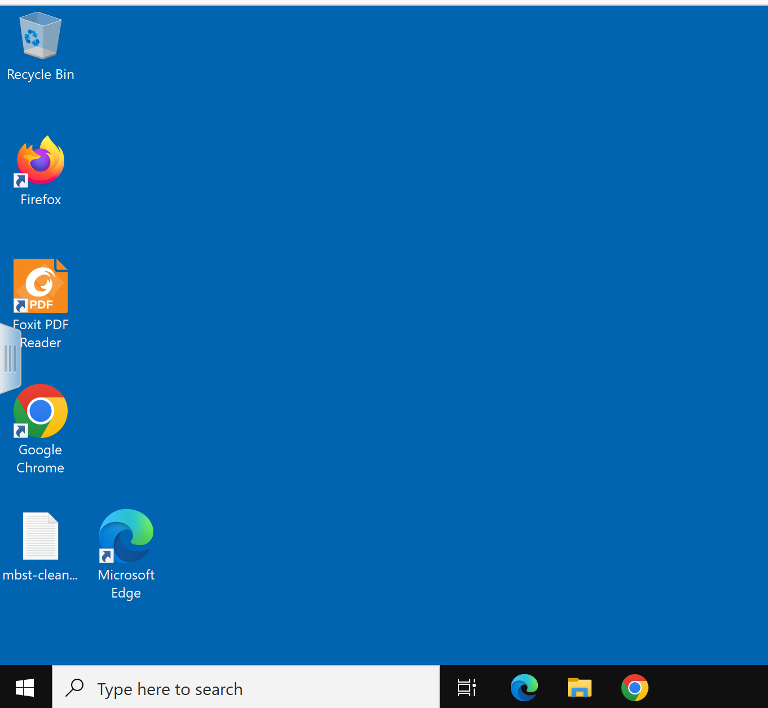

# Access the terminal from the windows desktop (in VMWare)

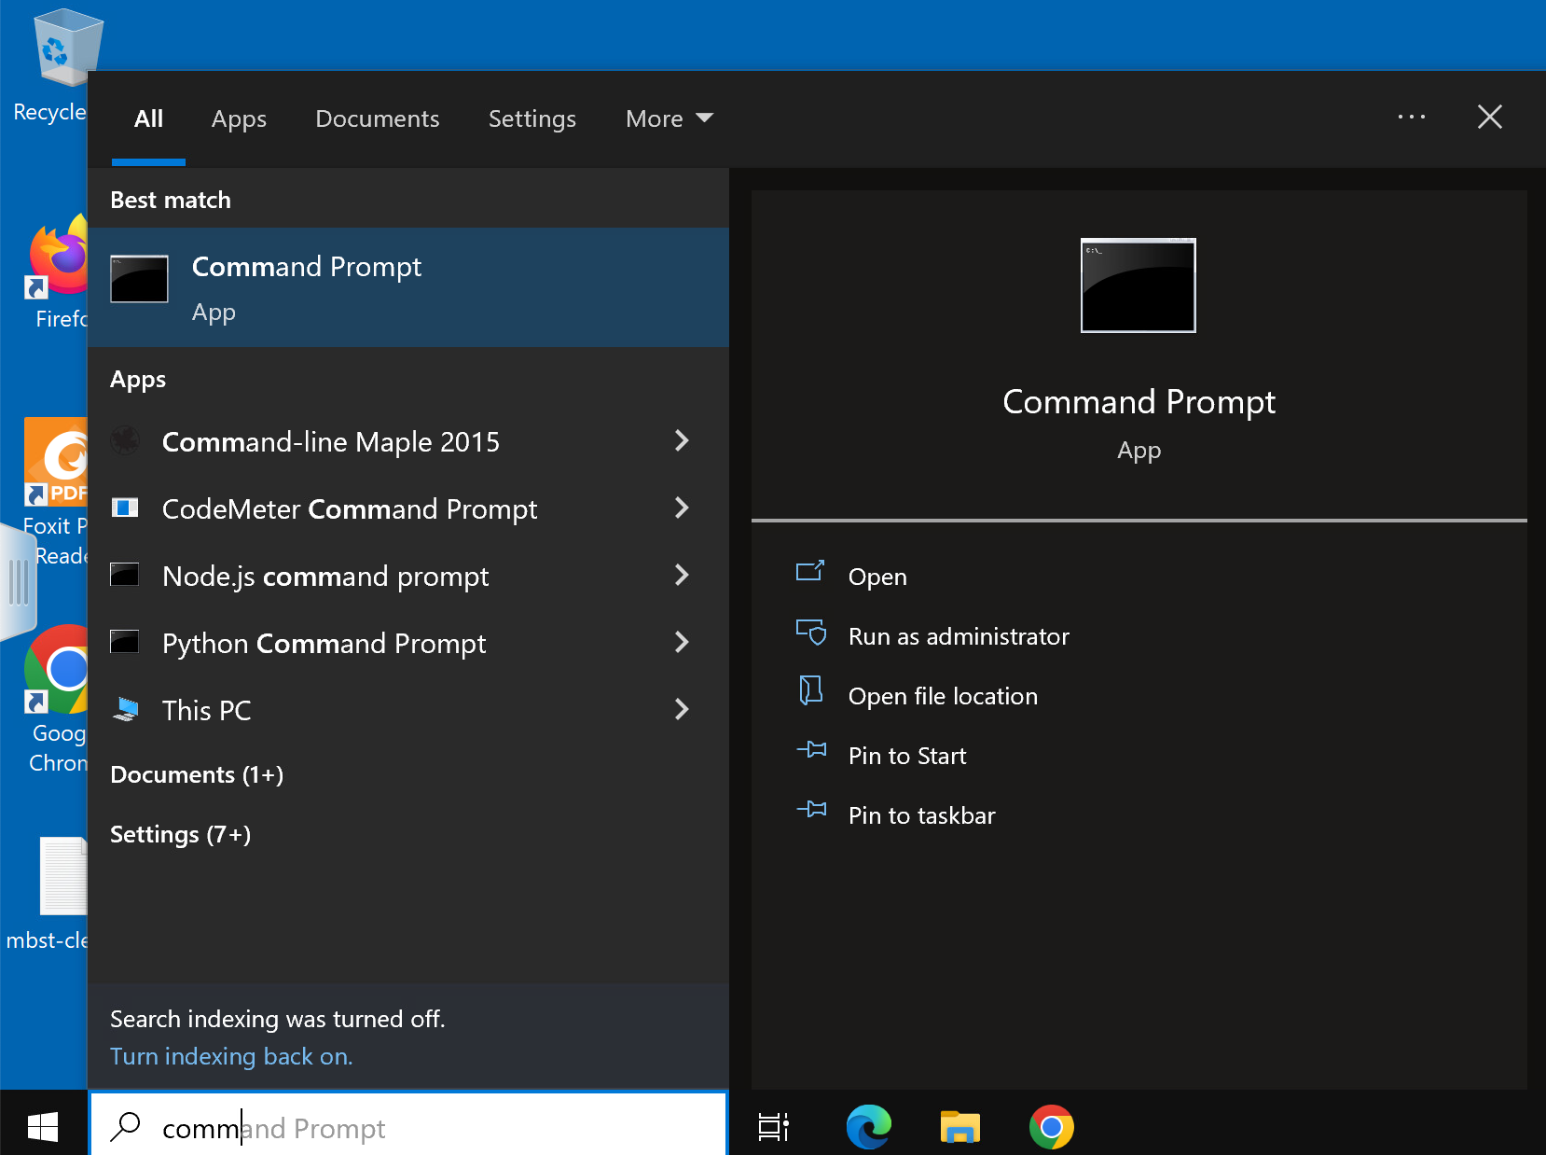

# SSH into oraclelinux.eng.fau.edu

**At the prompt type ssh your_user_name@oraclelinux.eng.fau.edu**

**your_user_name is the name for your FAU email address, i.e. rraven2021@fau.edu**

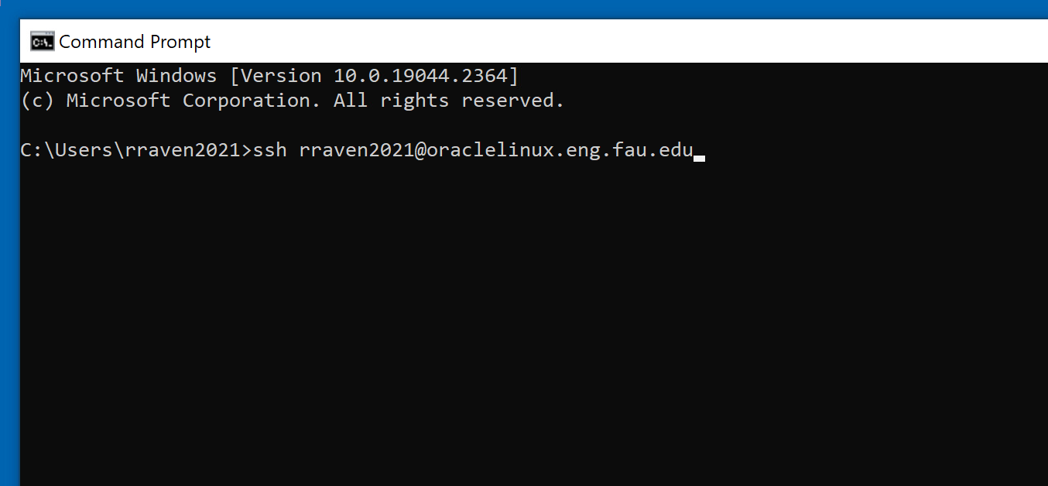

**Default password is “oracle”**

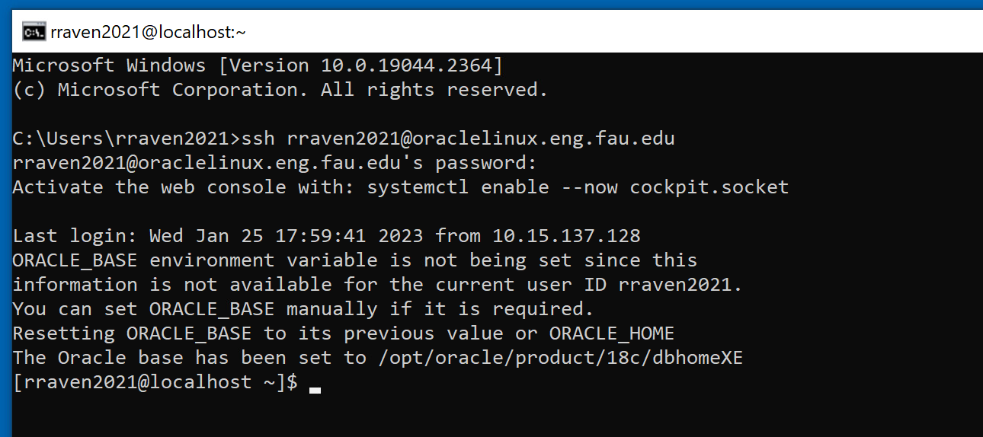

# Enter Oracle database server with SQL*Plus command

**At prompt type sqlplus your_user_name**

**Default password is “oracle”**

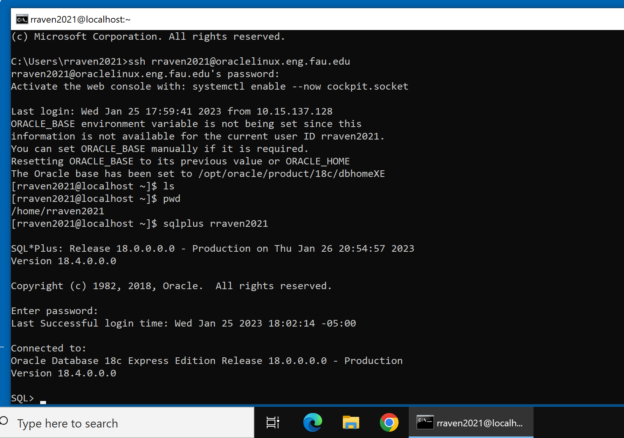

# Create table (example)

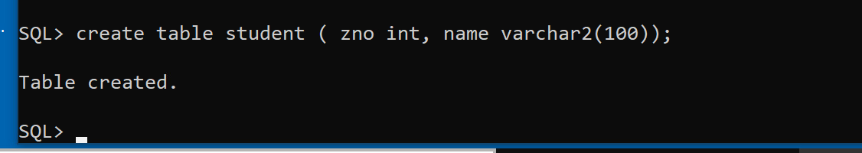

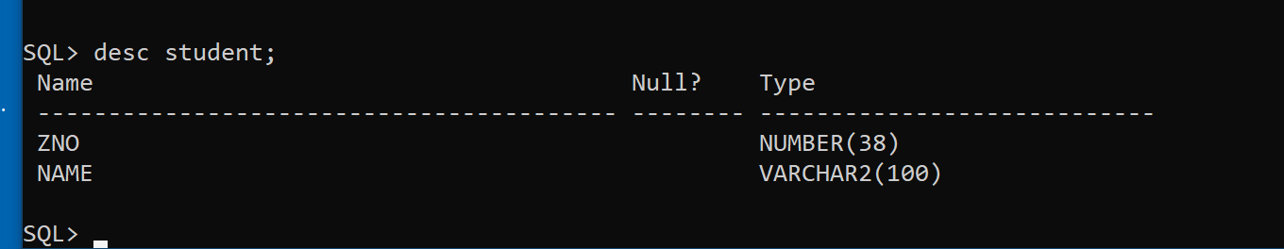

Create row

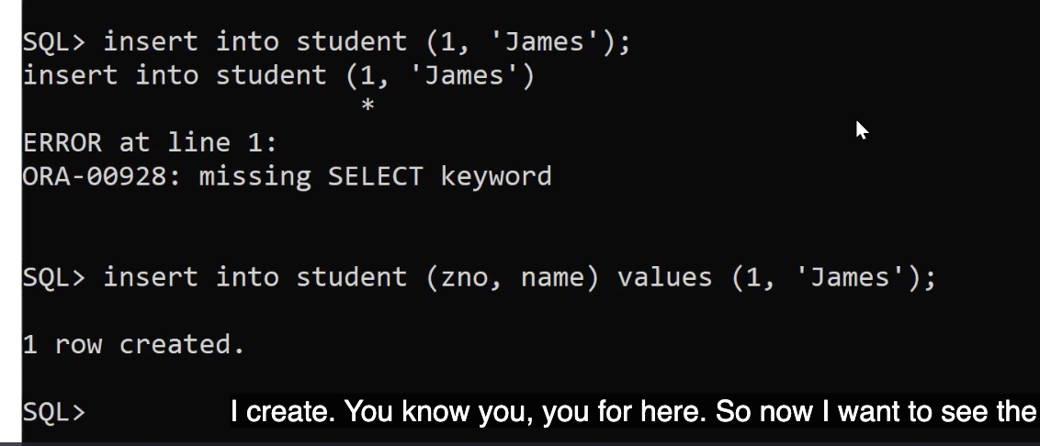

(optional) set linesize 200; for more organized output

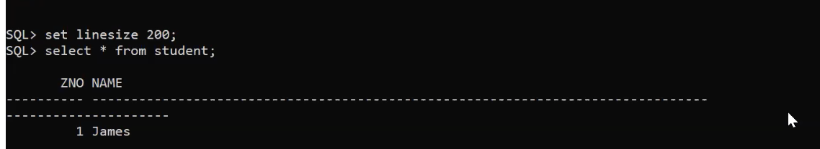

# Create spool file

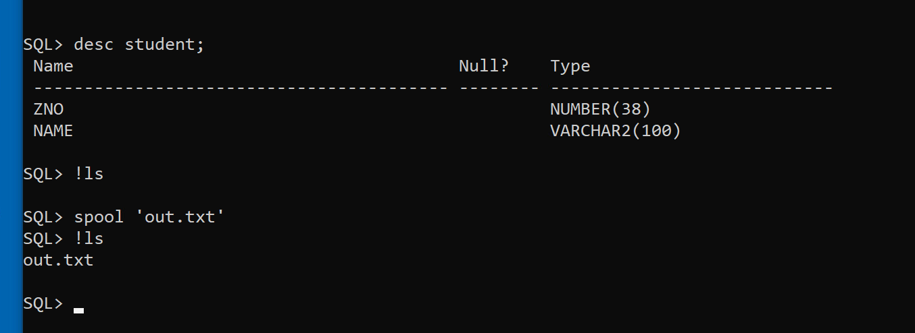

Run queries

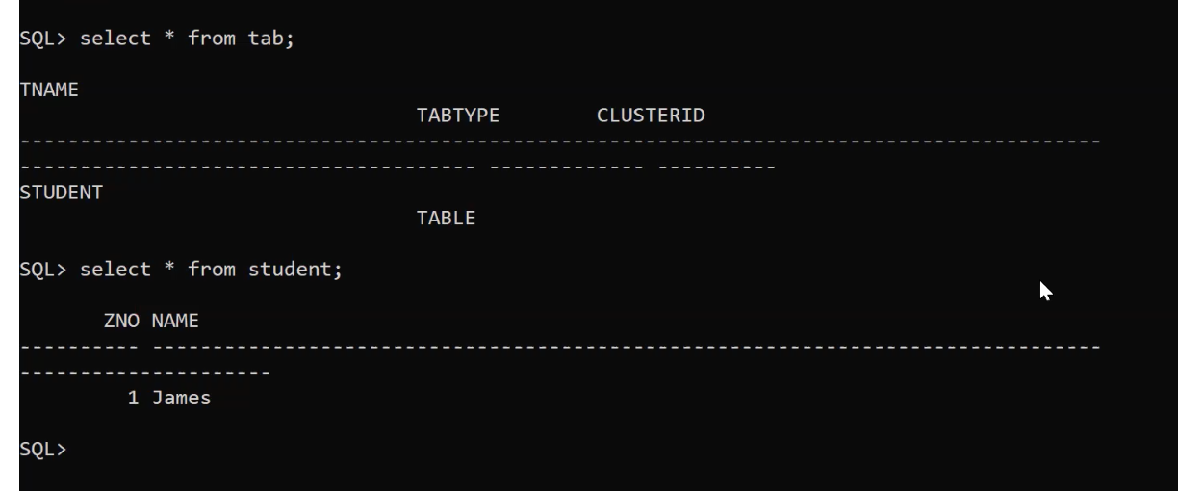

# End spool file with spool off command & then exit

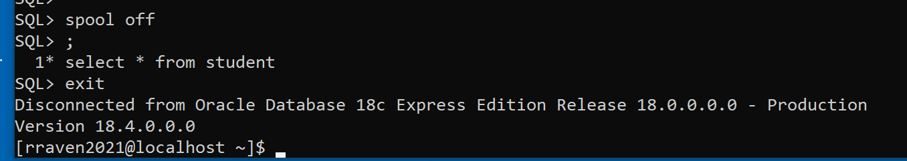

# Verify spool file is present with either ls -al or ls

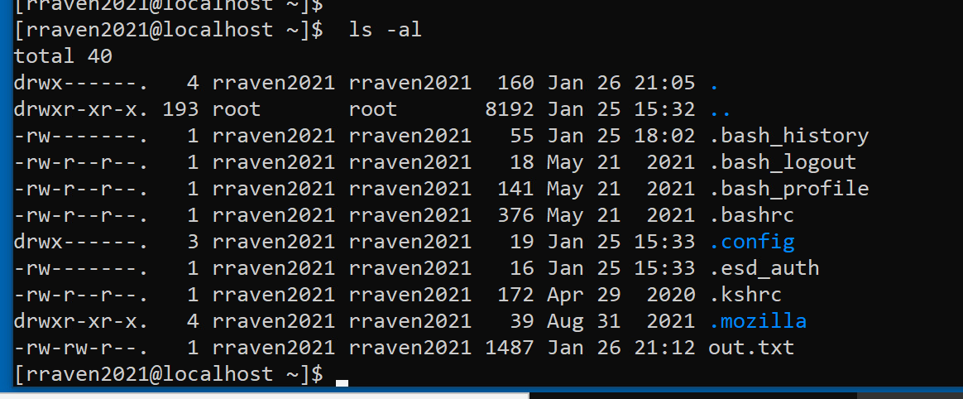

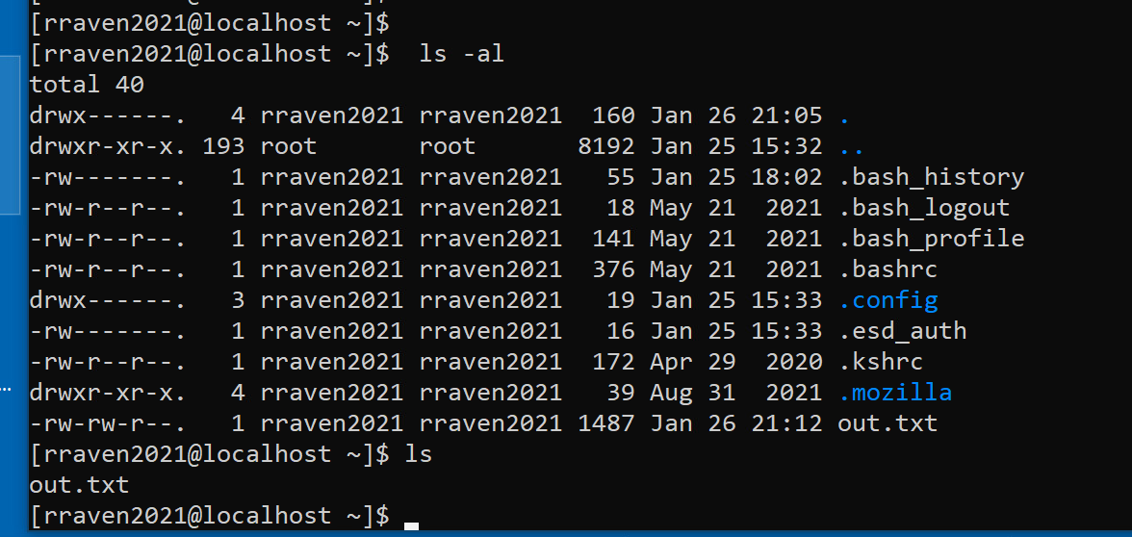

# Exit to VMware desktop

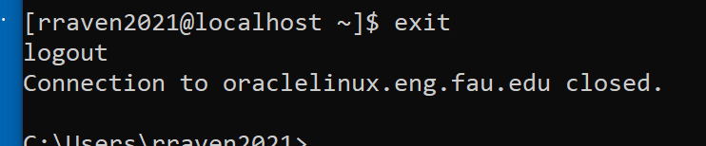

# sftp to get spool file and download it to VMware desktop & exit

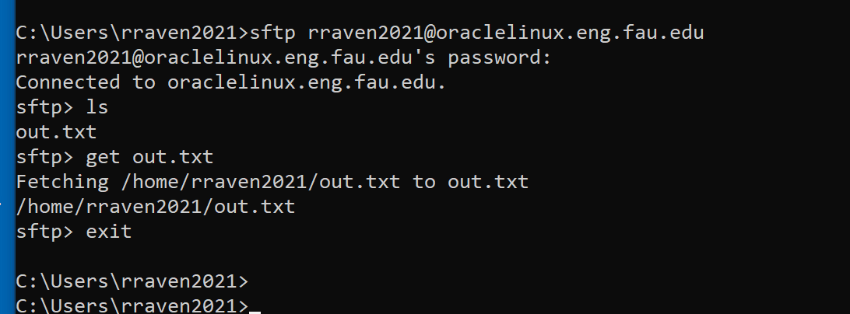

# Find spool file in VMware desktop

This PC -> Local Disk (C) -> Users -> your_user_name

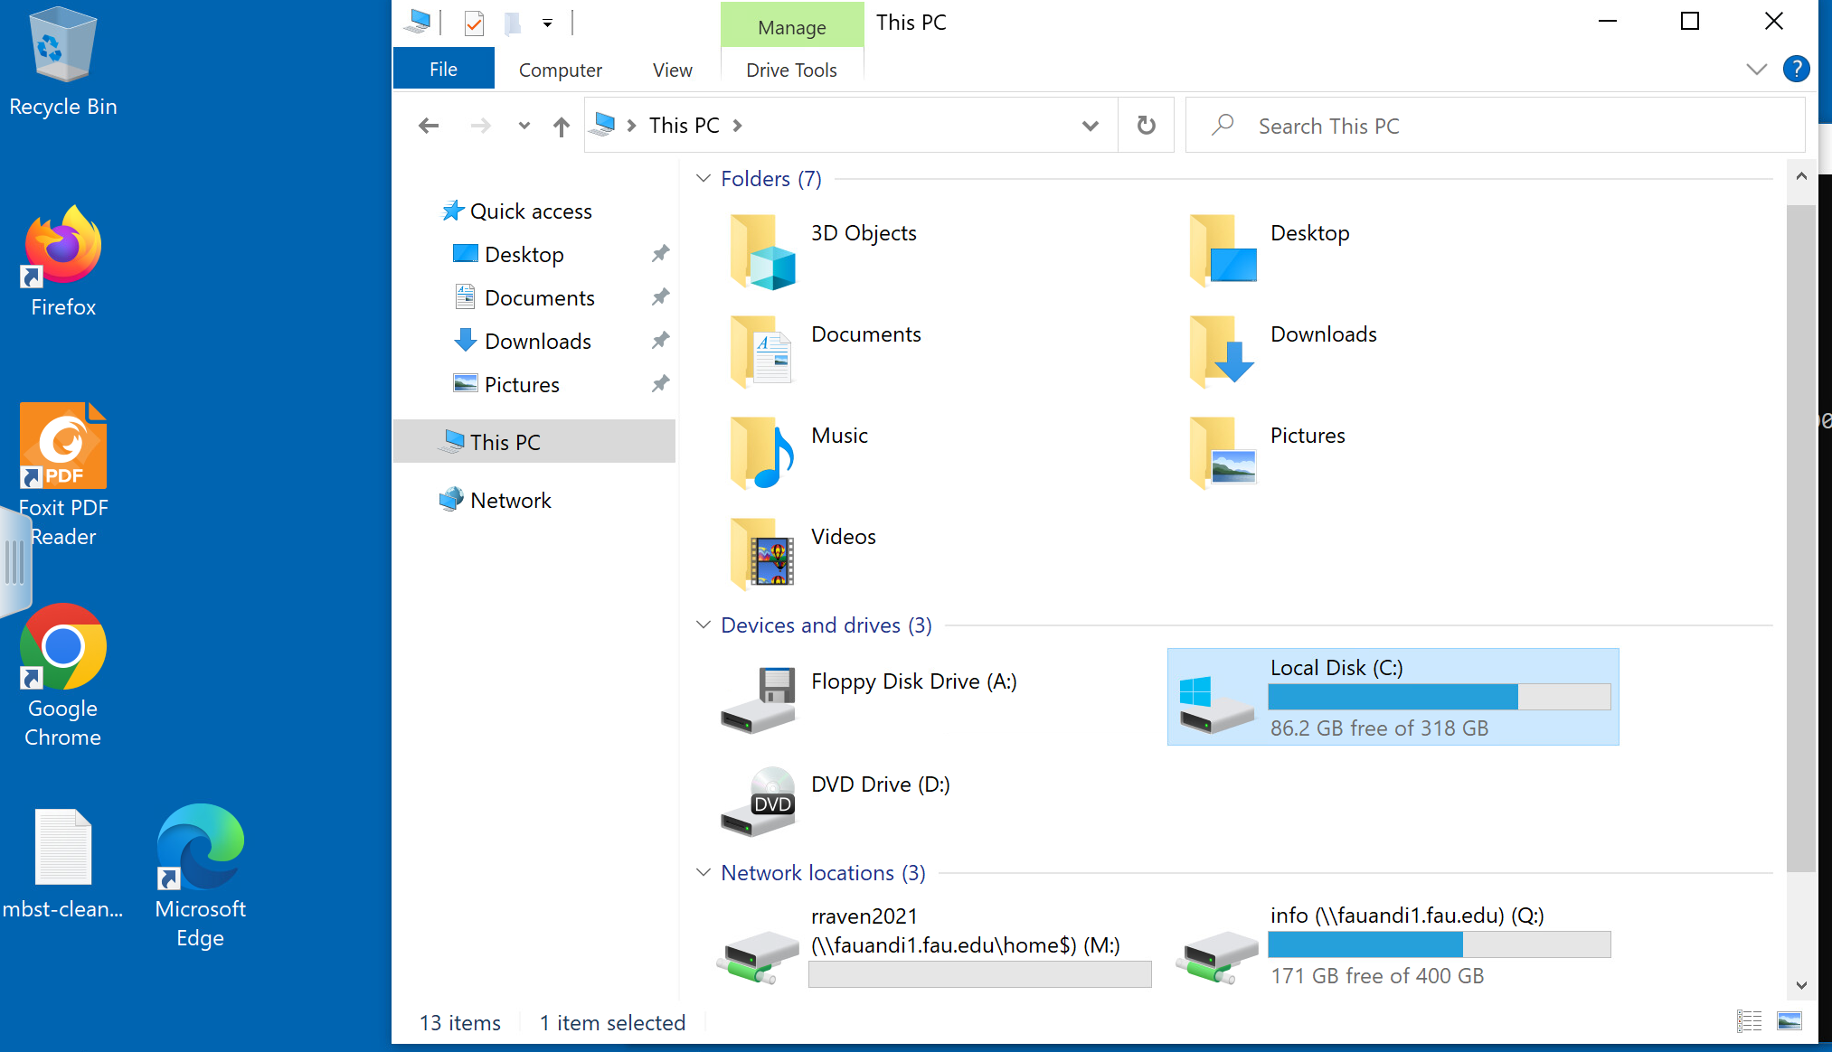

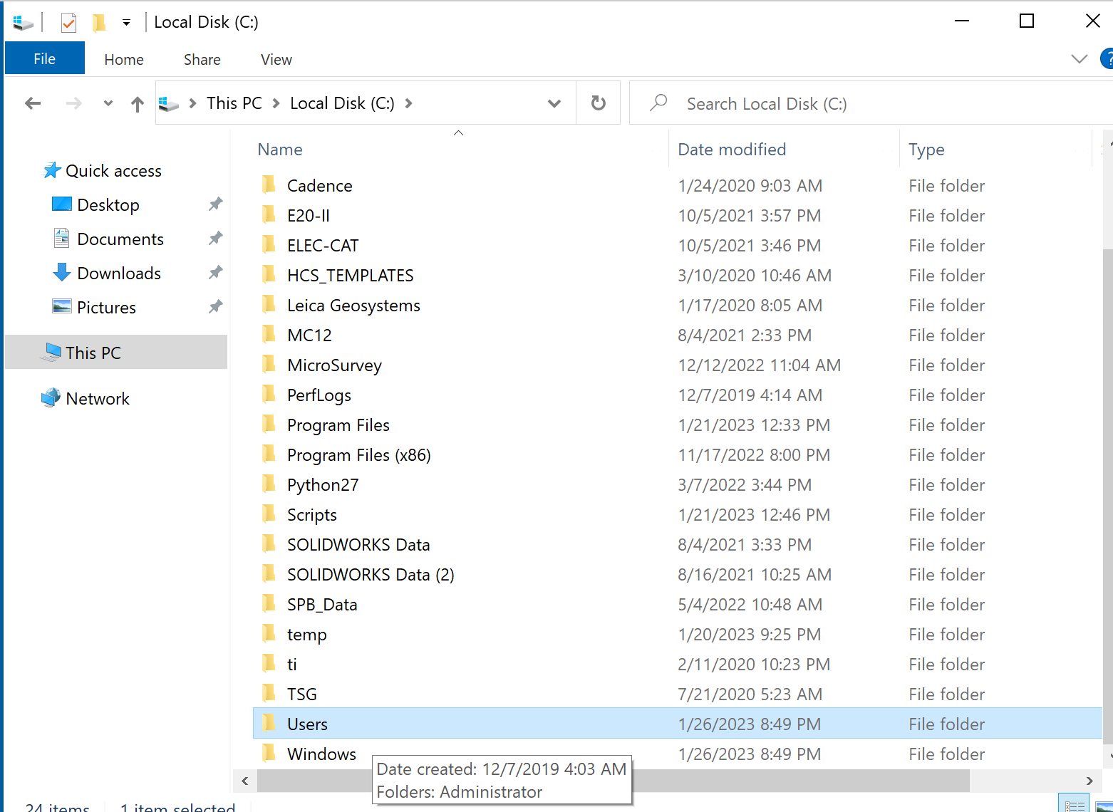

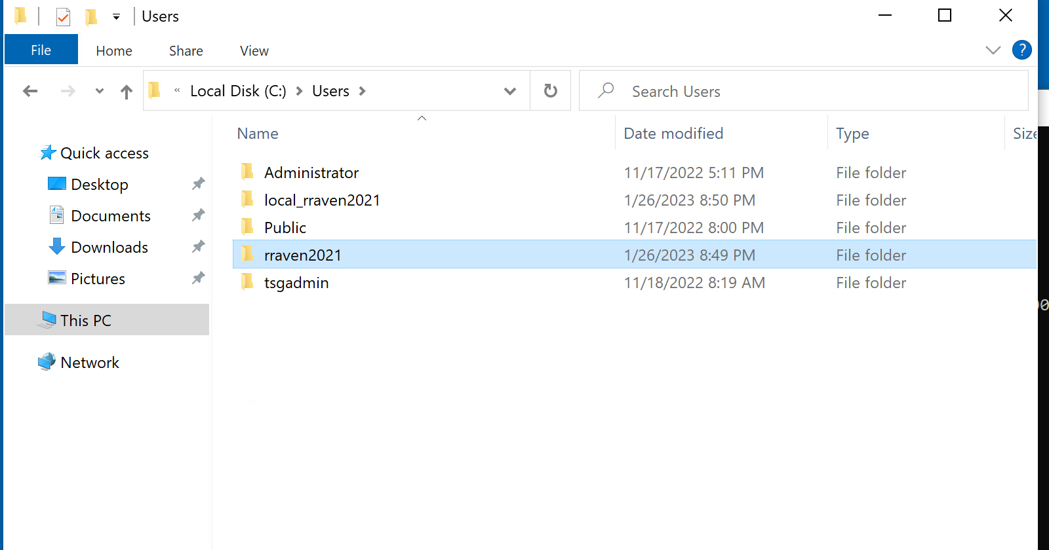

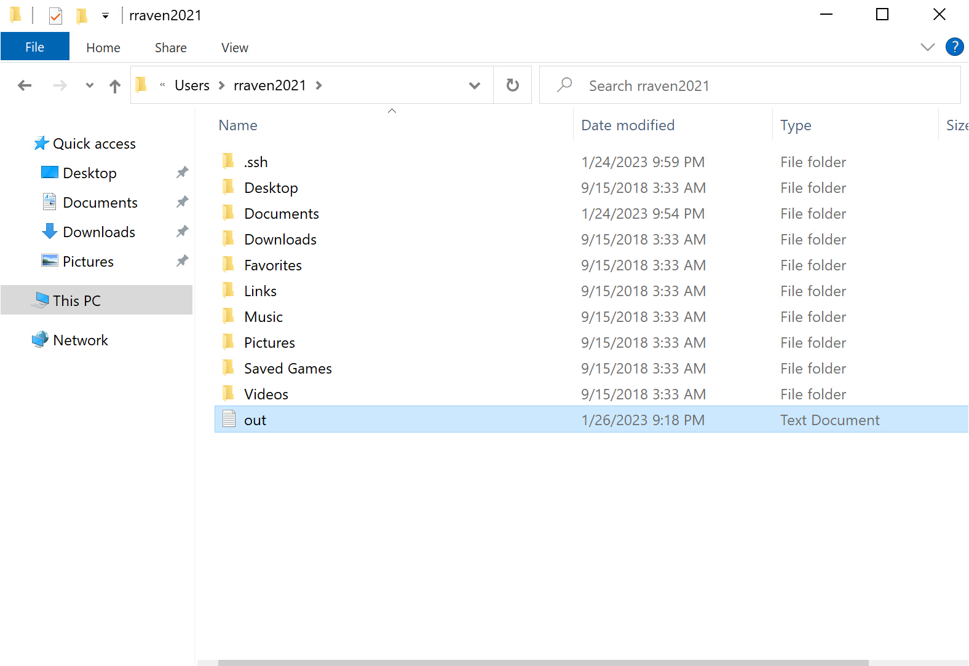

# Make sure the spool file has all the SQL queries and the correct output

Right click and select Notepad ++ to view file

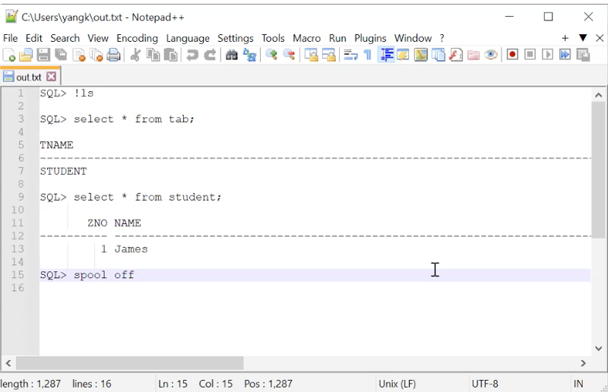

Or double click to view in Notepad

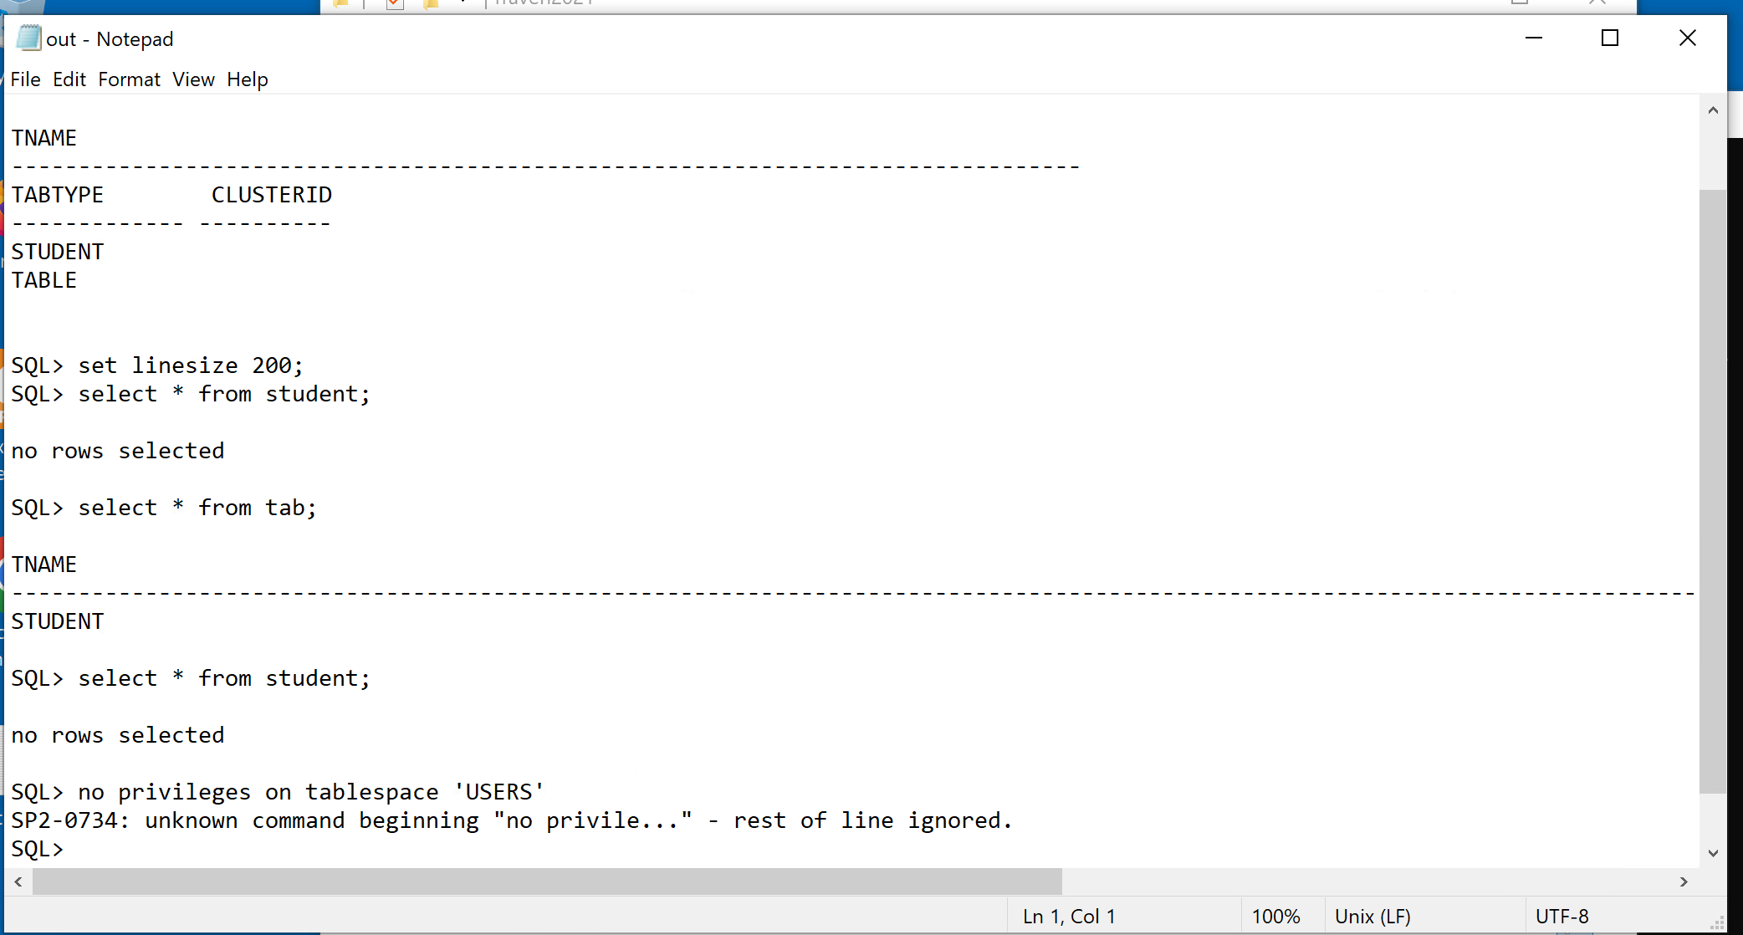

# Upload the spool file from the VMware desktop

Log in to myfau

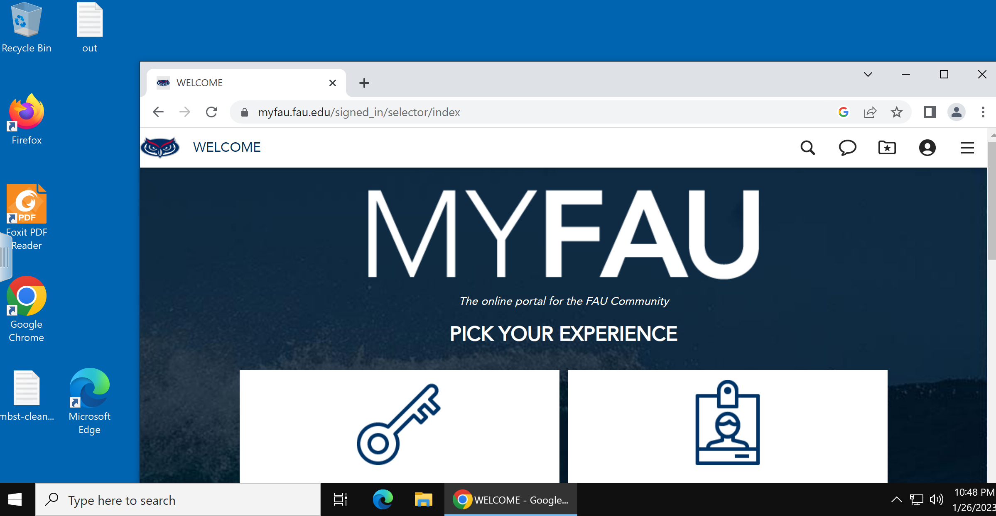

Upload the spool file as part of the homework submission

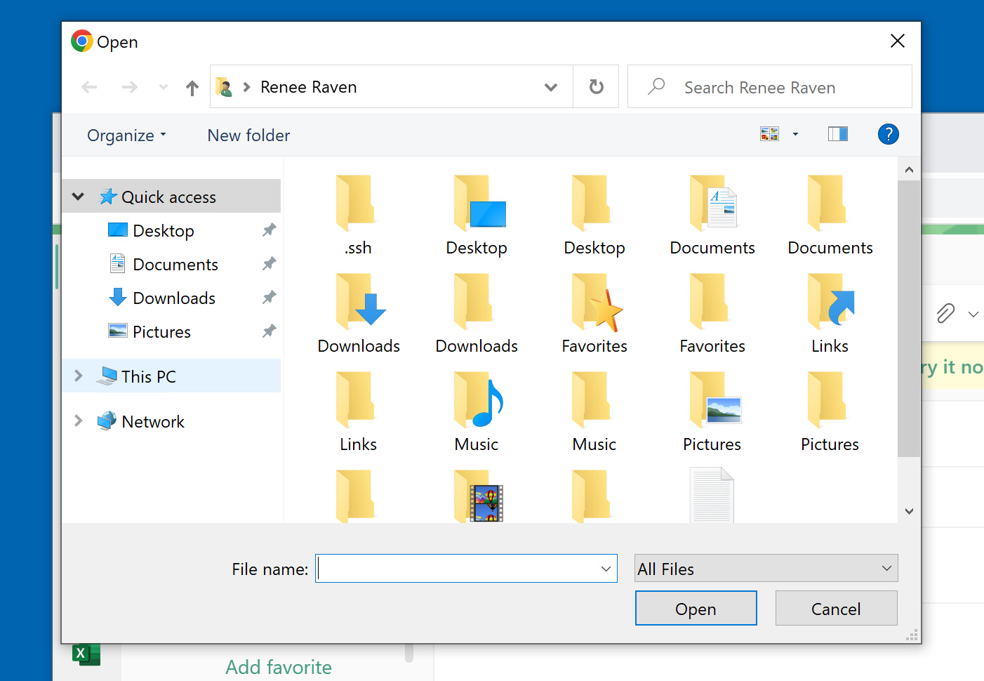

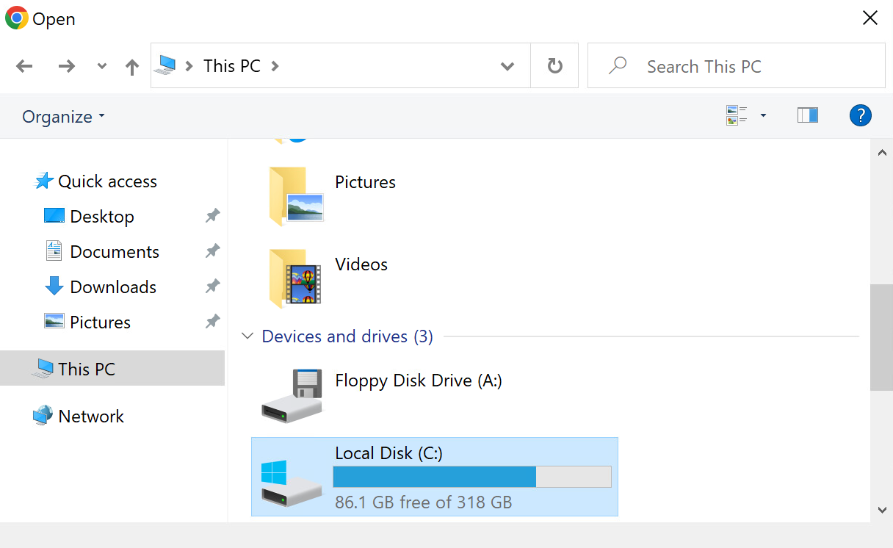

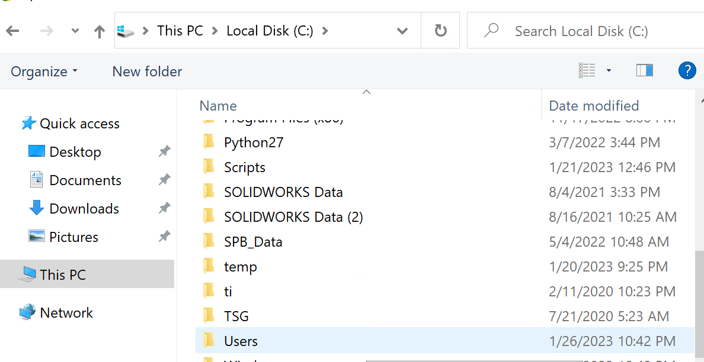

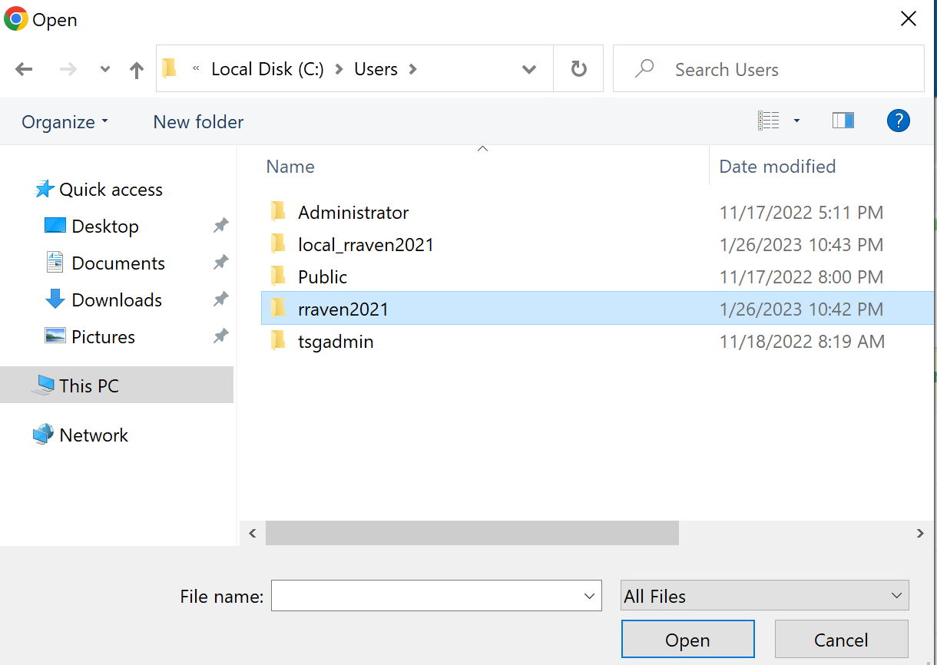

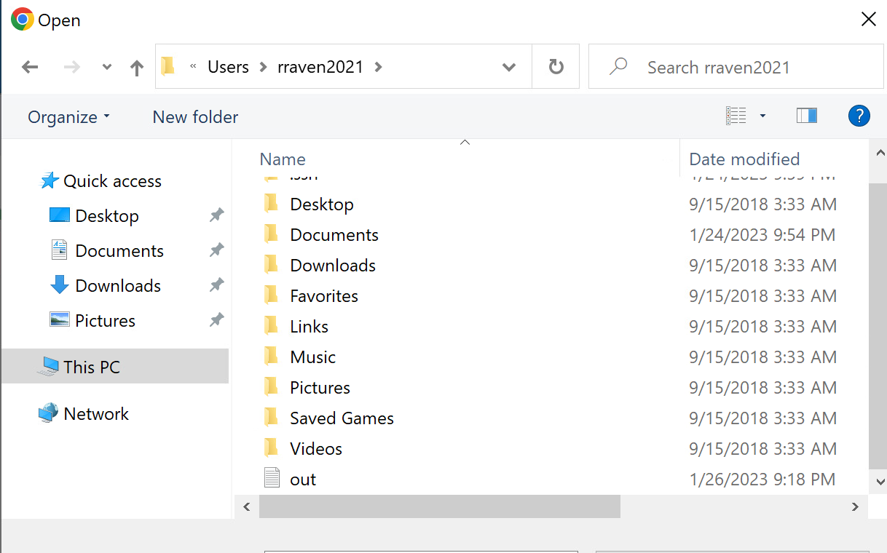

# Change linux password

›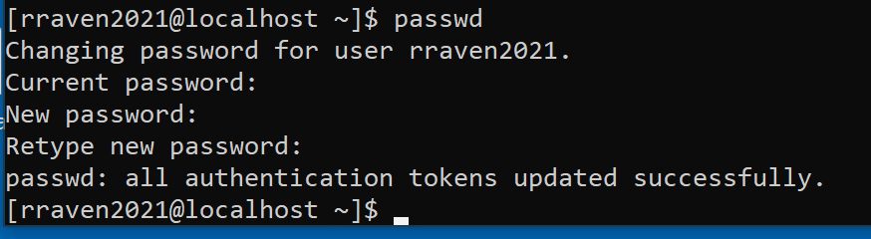

# Change Oracle password

